 | 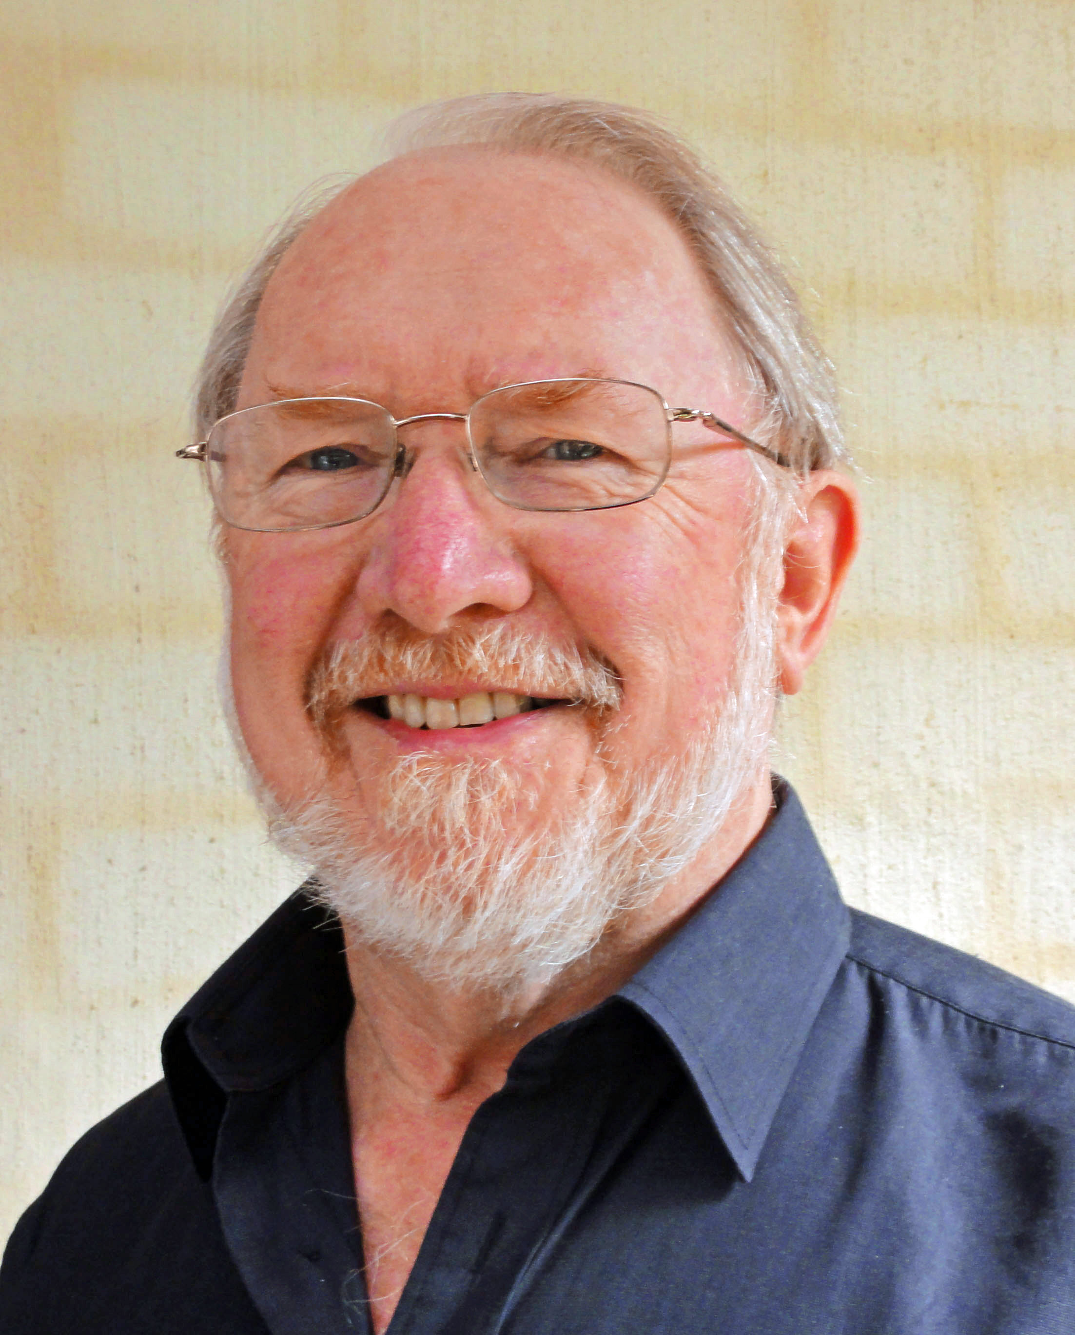

WILLIAM R CHANDLER OAM

BArch DipT&RP MEngSc LFPIA MRTPI

Bill Chandler, a highly experienced city planning, transport and design consultant, is Director of Chandler Consulting Services Pty Ltd. He specialises in planning strategy and urban design, proposing and critically assessing policies and projects, and devising functional, attractive and efficient places for communities to live.

Bill was awarded an Order of Australia Medal for services to town planning and urban design. He is a Life Fellow of the Planning Institute of Australia and has been honoured at a State and National level with a Lifetime Achievement Award for his leadership and advocacy for the better planning and design of cities and towns, his work on many major projects, and his initiatives with Urban Design Forum and PIA.

With formal qualifications in Architecture, Town and Regional Planning, and Engineering Science/Transport, Bill has more than four decades of professional experience working primarily in Australia, with proactive networking and research experience in UK, Europe, North America, Asia and New Zealand. He has undertaken ten overseas tours – short intensive private initiatives to test a best-practice approach for Australian projects. His tours included Dubai, Shanghai, Singapore, Venice, Istanbul, various locations in UK, Italy, Germany, Washington DC, New York and Boston.

The major benefit of this travel is first-hand critical observation and conversation with key people. The key intent is analysing policies and projects where comprehensive strategic planning and urban design excellence are crucial contributors in the transformation of communities and cities that are successfully addressing the challenge of major change in economic, social and environmental circumstances.

Urban sustainability, in the context of global warming and world financial and energy realignments, provides an important focus for the research Specific interests include: intensity and diversity of development; fully integrated access and transport (including walkability and cycling); approaches to affordable housing; housing/employment interaction; and the central role of urban design in creating and managing robust urban places.

Bill has worked extensively for all levels of government, the private sector, institutions and the community sector on both major projects and detailed design. Key professional roles include:

- Senior executive roles including Director of Planning and Urban Design, and Director of Marketing and Public Affairs with Melbourne Docklands Authority
- Director and Principal of Chandler Consulting Services Pty Ltd, involved in a wide range of special planning, transport, and design projects, including consultancy and in-house team projects with government
- Director of the Loder and Bayly Consulting Group, prior to the group merging with SKM/EDAW, where he played a key role in establishing the Brisbane office as well as managing major inter-disciplinary planning and design projects across Australia.
- Early career experience based in London and Singapore.

Cities and towns are complex and dynamic. In his strategic planning work, Bill works at the technical, economic, physical, environmental and social interfaces, always recognising that the political/governance dimensions are critical for implementing good ideas. Taking a disciplined but creative approach to situation analysis and problem-solving, Bill employs techniques such as ‘backcasting’ and ‘what if scenarios’ to address complex issues - particularly where traditional linear analysis is unable to achieve acceptable and adequate outcomes.


With the aim of optimising the benefits of private and public investment, Bill works closely with technical advisors, senior bureaucrats, political personnel, and private design and planning companies. He has played a major role in large projects including Brisbane Inner Suburbs Action Plan (Brisbane City Council) and Future Perth Project, (Western Australian Ministry for Planning), and has advised on high-level review of government and institutional projects in Victoria (eg Metropolitan Strategy Melbourne 2030/Melbourne@5Million; University of Melbourne 20 year Campus Planning and Design Framework; priority project assessment; major activity centres programs, and road/rail projects for Local Councils and the State Government).

Asking the right questions is invariably a critical precursor to devising the best solutions, where the primary focus is to achieve the practical benefits of comprehensive, holistic and inclusive planning and design. Bill has specialised in land use/transport integration and the built environment, where issues of environmental sustainability, quality design and community expectations are an integral part of the solution.

Bill’s experience bridges large scale projects with the implementation of small scale details. He is particularly skilled at listening to peoples’ needs and assessing diverse data emanating from various professional disciplines, as well as considering the communities affected by planning and design decisions. His projects invariably involve working closely with a range of people with diverse values and interests – developers and investors, local communities, professional specialists, senior bureaucrats, and politicians – to achieve practical outcomes in complex circumstances.

His breadth of analysis and understanding of urban planning, urban design, and development is extensive. He has played a key role in a range of projects where the need for the work has been a result of relatively unplanned transitions involving the complex circumstances of urban change and growth. Recognising that urban design is a primary tool for both community engagement and project implementation, Bill has been a creative advocate and practitioner, a founder of Urban Design Forum in 1986, editor of the widely read Urban Design Forum quarterly, and co-editor of the book: ‘Urban Voices - celebrating urban design in Australia’ (UDF 2013).

In his Masters program on land use/transport integration, (recognised by the Planning Institute of Australia with awards at both the State and National level) the research highlighted the critical role to be played by Local Government in overall city planning, development approvals, and urban design.

At a personal level, Bill was independent chairman of the Victorian State Urban Arts Unit, co-founder and ongoing convenor of Urban Design Forum, he has taught part-time at a number of universities, and is Adjunct Professor at Deakin University. He was a member of the Victorian Minister’s Design Advisory Council, a member of the Minister for Planning’s Priority Development Panel, and a member of the Victorian Design Review Panel. He regularly makes presentations to professional and community groups, and is co-editor of Planning News, the Planning Institute of Australia’s monthly magazine.

Being very active in his local community, Bill has played a leading role in the establishment and management of a Neighbourhood Centre, festivals, and a local newspaper. As a founding member of the LighterFootprints, he is committed to effective climate change action and strengthening communities. He enjoys media advocacy, making music, and creative humour in influencing positive change.

Bill is a past-president of PIA (Vic), and has both organised and presented papers at numerous conferences in Australia, New Zealand, UK, Europe and USA. His most recent papers have addressed: the globalisation/localisation interaction; the adaptability/sustainability equations for planning and design; the importance of rational economics in devising and appraising projects; the effect of the ‘fear factor’; walkability in cities and towns, and the critical importance of innovative governance and financing tools for implementing robust ideas - all of these being concepts and aspects of research which Bill is currently using in advocacy, practical planning, effective design, and action

For further information, Bill can be contacted at:
Email: wchandler@bigpond.com
Phone: +61 0419 762 760

